Senior Design(Prof:Gertner).

LiveTranslation app

Software Design Report

Web Application

Version 1.0

LiveTranslation

Software Requirements Specification

<document identifier>

Version: 1.0

Date: 25/10/2017

Revision History


Date |  | Version |  | Description |  | Author
25/10/2017 |  | 1.0 |  | Preliminary stages |  | Mohamed Sondo
 |  |  |  |  |  | Jim Scherer
 |  |  |  |  |  | Mathew Tamayo

Confidential ©Senior Design with Prof:Izidor Gertner., 2017 Page 3

LiveTranslation

Software Requirements Specification

<document identifier>

Version: 1.0

Date: 25/10/2017

Table of Contents

- Introduction
1.1. Purpose

1.2. Scope

1.3. Definitions, Acronyms, and Abbreviations

1.4. References

1.5. Overview

- Overall Description

2.1. Use-Case Model Survey

2.2. Use-Case Reports

2.2.1. Registration

2.2.2. Login

2.2.3. Managing personal accounts

2.2.4. Managing Contact

2.2.5. Chat Profile

2.2.6. Video Chat profile

2.2.7. Text to Speech

2.2.8. Translation

2.2.9. Preparing the menu

- Entity Relationships 3.1. E-R Diagram

- Detailed Design

4.1. Pseudo-code

4.1.1. Registration processing

4.1.2. Login processing

4.1.3. Chat System

4.1.4. Video Chat system

4.1.5. GUI sequences

- System Screens

5.1. Homepage screens

5.1.1. Homepage (User Profile)

5.1.2. Homepage (Chat Board)
5.1.2. Homepage (Video Chat Board)

5.2. Registered users

5.2.1. Account settings

5.2.2. Sign In
5.2.2. Sign Out

5.5. Searching and browsing

5.5.1. Search as non-registered user

5.5.2. Search as registered user

5.5.3. Search results

5.6. Contact List

5.6.1. Contact control panel

Confidential ©Senior Design with Prof:Izidor Gertner., 2017 Page 4
LiveTranslation

Software Requirements Specification

<document identifier>

Version: 1.0

Date: 25/10/2017

Software Requirements Specification

- Introduction

1.1 Purpose

This documentation provides a detailed description of the LiveTranslation Multilingual Translating Chat App system and analyzes the different subsystems within this web application. As it is a Mobile application for first release, this document explains the features of the interface available to the users, how the users will interact with the application, and how the application will respond to these interactions. This document will also describe the reliability of its dependencies such as APIs and libraries published by third parties.

1.2 Scope

LiveTranslation is a live translation chat app system which allows individuals to chat with relative across the globe in supported languages. Users, potential (sender and receiver), are given a profile view to the app based on their submitted credential, allowing them to view Chat room of their setting as well as the video chat and contact list menus. Upon initializing a chat room with another contact (either regular or video Chat), the Users can communicate with the other end user in our language which will be translate to another one in the other hand. The language choice will be up to both users and supported translation services available in the app release.

Moreover, LiveTranslation gives certain responsibilities to users besides – the sender or the received. These responsibilities include such things as configuring chat setting, language choice, profile managing. Essential knowledge on the chat service utilization of the app.

1.3
Terms | Definition
User (Sender) | A User –need to register and has access to a control panel which handles customer
User (Receiver) | registrations and work status of its employees (hire/fire/promote).
Non-registered | feedback for the restaurant.  A visiting user who can only browse/the app and cannot initial chat prior registration
System (SY) | The system provides checkpoints for specific actions of the system’s users
Users Control Panel | A control panel specific to a manager user
Objective C

Swift

Java

WebRTC

Firebase

Google speech Api

Google map Api

Reference:
IEEE. IEEE Std 830-1998 IEEE Recommended Practice for Software Requirements Specifications. | IEEE Computer Society, 1998.

Definitions, Acronyms, and Abbreviations

Term Definition

User (Sender) |  | A User –need to register and has access to a control panel which handles customer
 |  | registrations and work status of its employees (hire/fire/promote).

User (Receiver)

Delivery
and Google+.

Confidential ©Senior Design with Prof:Izidor Gertner., 2017 Page 5
LiveTranslation

Software Requirements Specification

<document identifier>

Version: 1.0

Date: 25/10/2017


1.5 Overview

The remainder of this specification will detail the functionality of this web application

The second, following section will provide a brief description of the application by reviewing use-cases and dependencies.

The third section provides some better details of the applications not included in it’s prior sections and uses more specific definitions to describe different use-cases and dependencies of this application.

Confidential ©Senior Design with Prof:Izidor Gertner., 2017 Page 6
LiveTranslation

Software Requirements Specification

<document identifier>

Version: 1.0

Date: 25/10/2017

- Overall Description

2.1 Use-Case Model Survey

The following diagram provides a visual to available features of the application unique to each user.
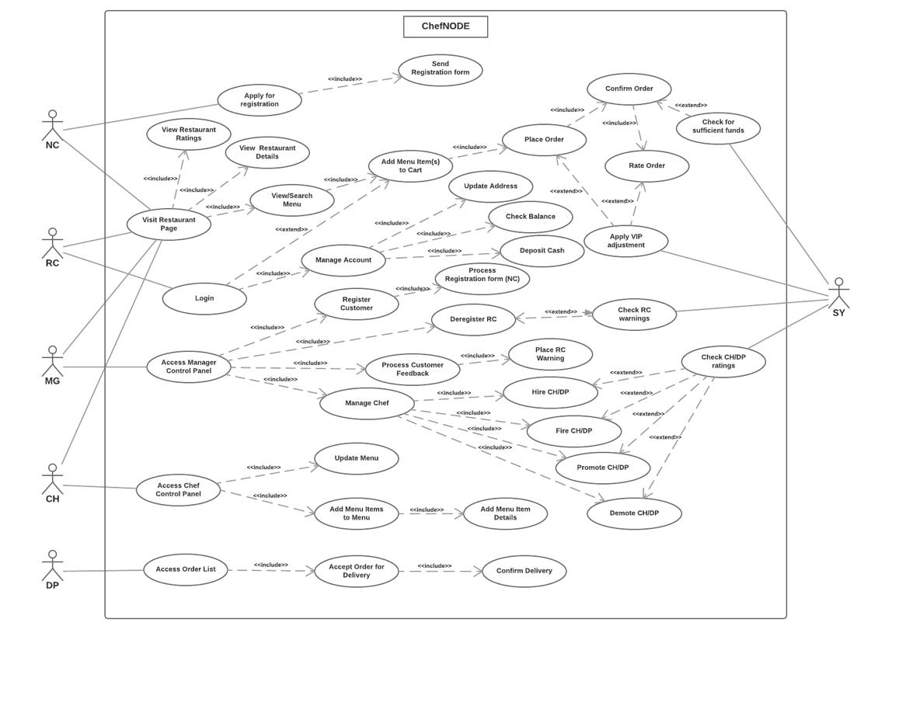

2.2 Use-Case Reports

2.2.1 Registration

Use case diagram:
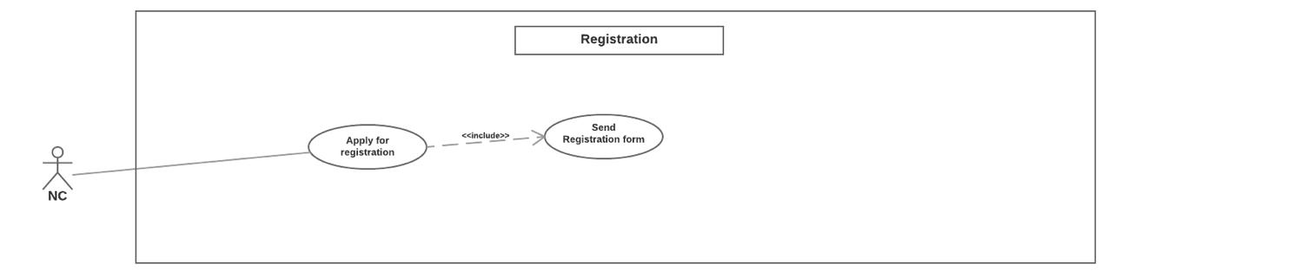

Collaboration diagram:

Confidential ©Senior Design with Prof:Izidor Gertner., 2017 Page 7
LiveTranslation

Software Requirements Specification

<document identifier>
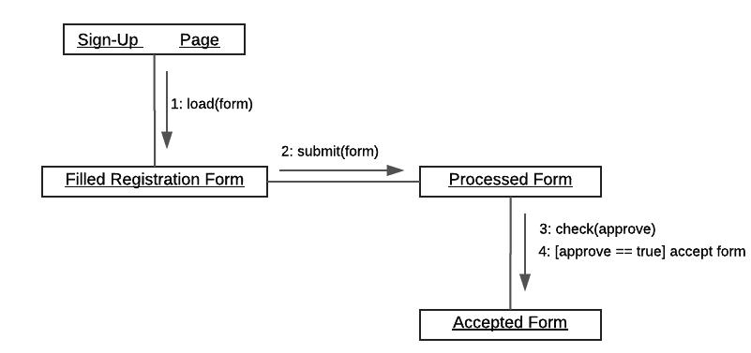

Version: 1.0

Date: 25/10/2017

Petri-net:
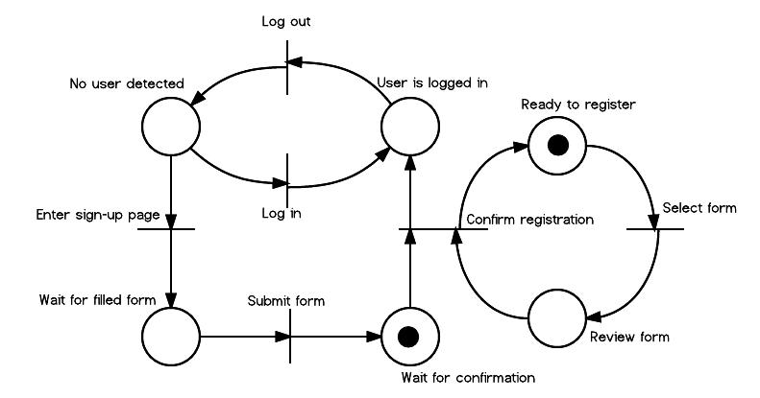

Description: Assuming the system is displayed properly to a visiting user, a non-registered customer (NC) can view a restaurant and its details. But, to place an order, the NC must first submit a registration form to become a registered customer (RC). Once an RC, the user gains multiple access controls for the system. Details:

- NC enters the “sign-up” page
- NC enters valid information on the sign-up form
- NC submits/sends the form and waits for approval
- MG views the form and approves, thus registering the customer
- SY creates an account for NC, which then becomes RC

2.2.2 Viewing a restaurant page

Use case diagram:
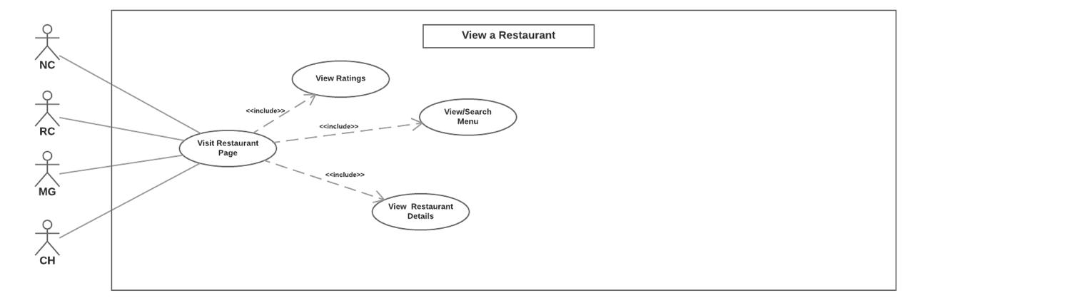

Collaboration diagram:

Confidential ©Senior Design with Prof:Izidor Gertner., 2017 Page 8
LiveTranslation

Software Requirements Specification

<document identifier>
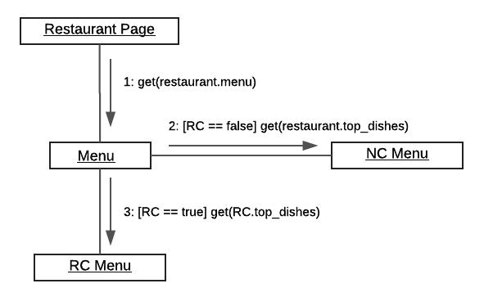

Version: 1.0

Date: 25/10/2017

Petri-net:
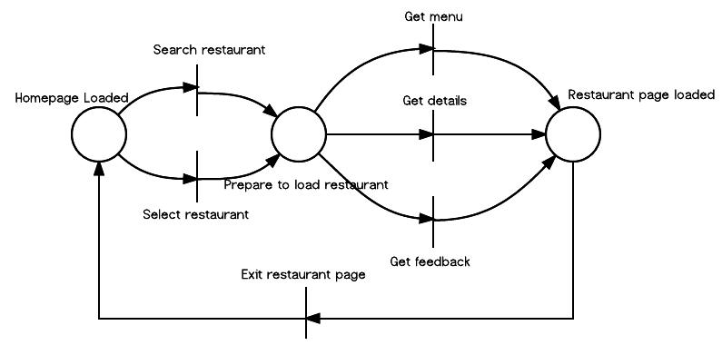

Description: All users will be allowed to view a restaurant page, which includes the ratings, menus, and

additional details of the restaurant.
Details:
- User connects to the website
- User browses restaurants and chooses a restaurant
- User views the restaurant’s page
- User views ratings
  - Ratings will be an average of feedback received by RCs who ordered from current restaurant.
- User views menu
  - The menu will present the top five most popular dishes at the top of the menu
- User views details
  - View vicinity and location of current restaurant
  - View hours of operation of current restaurant
  - View CH operating at the current restaurant

2.2.3 Placing an order

Use case diagram:

Confidential ©Senior Design with Prof:Izidor Gertner., 2017 Page 9
LiveTranslation

Software Requirements Specification

<document identifier>

Version: 1.0

Date: 25/10/2017
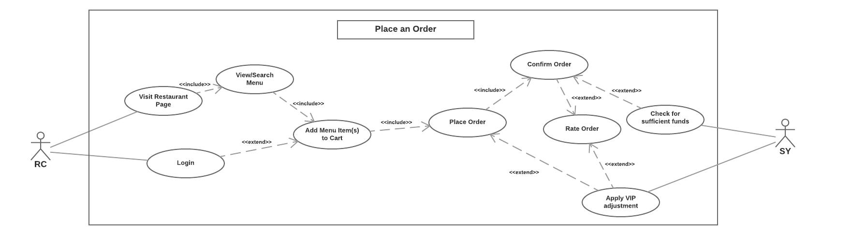

Collaboration diagram:
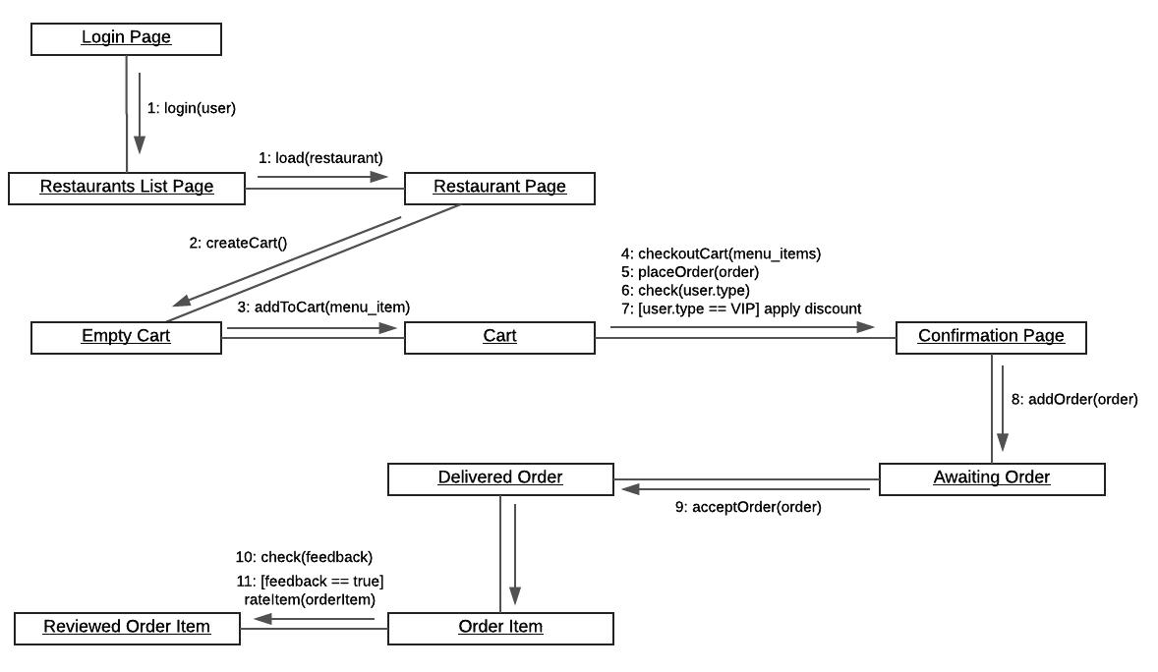

Petri-net:

Confidential ©Senior Design with Prof:Izidor Gertner., 2017 Page 10
LiveTranslation

Software Requirements Specification

<document identifier>

Version: 1.0

Date: 25/10/2017
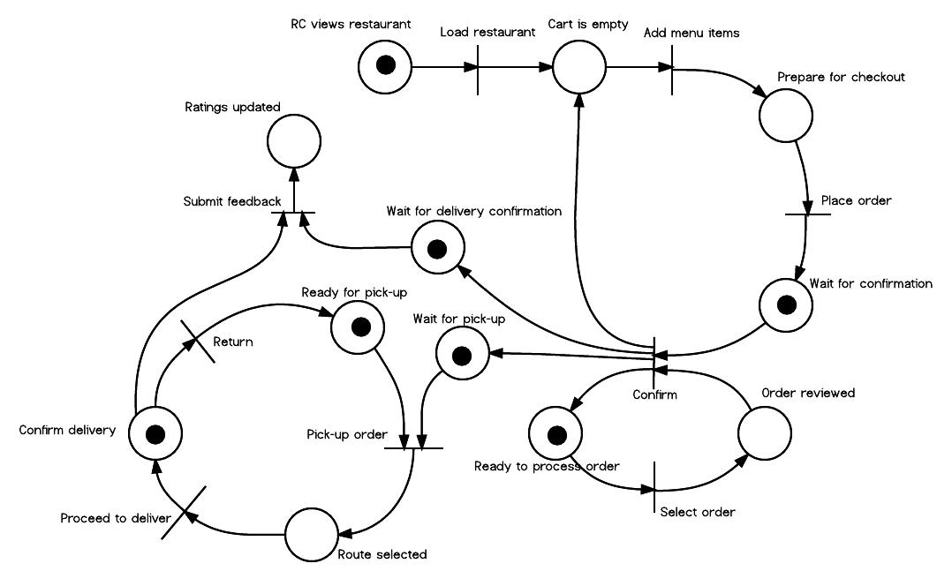

Description: Once registered, a user gains an online cart to add menu items from a menu of a restaurant.

Once the user has desirable items in the cart, the user can place the order.
Details:
- User finds a restaurant and entered the restaurant’s page
- User views and searches the menu of the restaurant
- User cannot proceed further unless the user is logged in as RC
- RC adds menu items to the cart
- RC places the order
- SY checks the RC for sufficient funds, and adjusts total
- Order is confirmed
- RC options to rate the order, and SY applies an adjustment to the rating

2.2.4 Managing personal accounts

Use case diagram
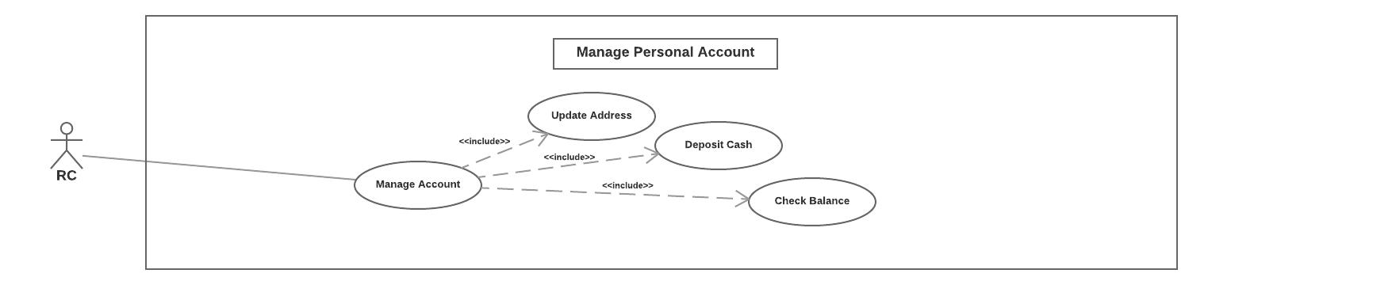

Collaboration diagram:

Confidential ©Senior Design with Prof:Izidor Gertner., 2017 Page 11
LiveTranslation

Software Requirements Specification

<document identifier>
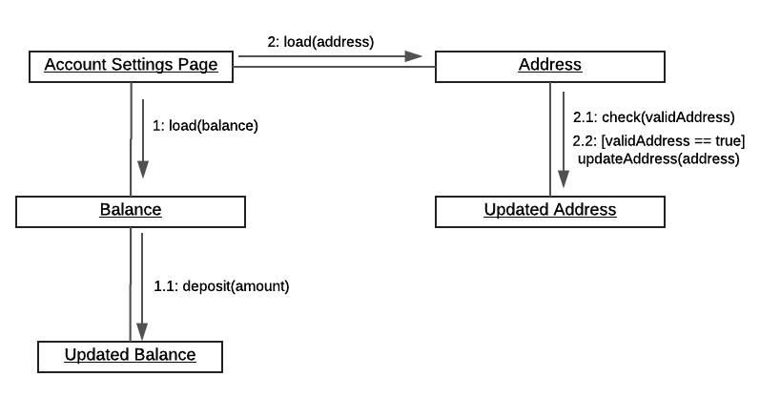

Version: 1.0

Date: 25/10/2017

Petri-net:
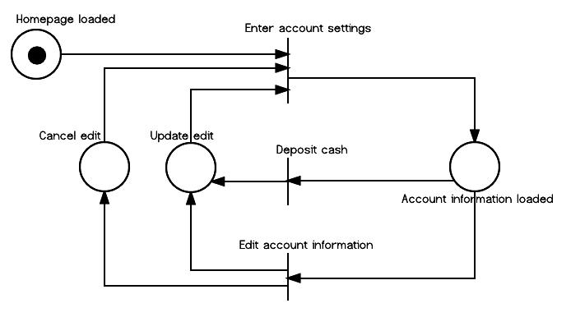

Description: A RC must manage the RC account to have a valid address and enough balance to place an

order.
Details:
- RC visits account settings page
- RC edits and saves address details
- RC transfers or deposits cash into the account RC can check the current balance

2.2.5 Processing registration status

Use case diagram:
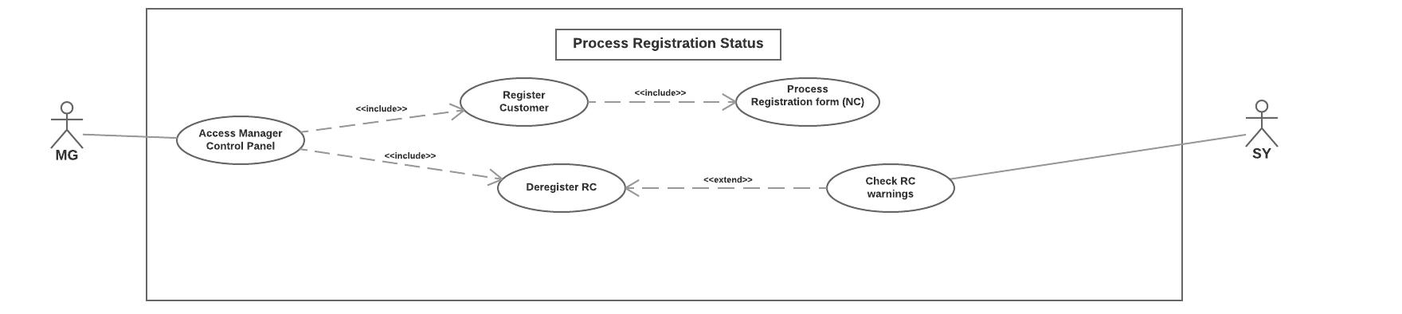

Collaboration diagram:

Confidential ©Senior Design with Prof:Izidor Gertner., 2017 Page 12
LiveTranslation

Software Requirements Specification

<document identifier>
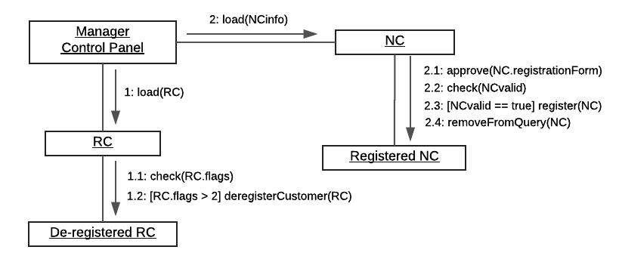

Version: 1.0

Date: 25/10/2017

Petri-net:
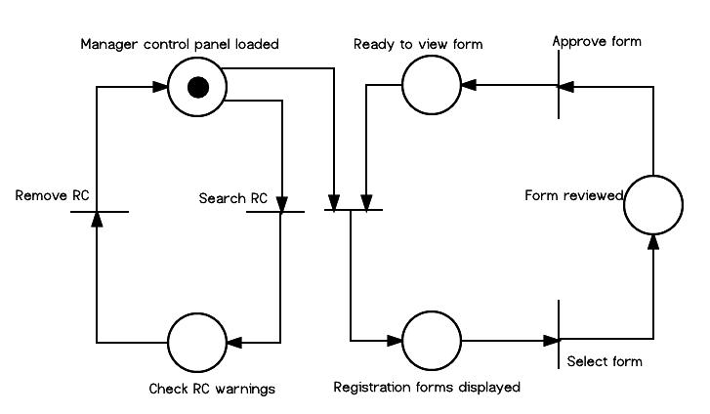

Description: MG is granted special access through the MG-CP (manager control panel). This control panel

allows MG to manage the system’s users.
Details:
Registration process:
- User logs in as MG
- MG views submitted forms
- MG reviews a specific form
- MG accepts form and a RC account is created De-registration process:
- User logs in as MG
- MG views RC and prepared to de-register
- SY checks RC account for a specific number of warnings
- SY allows de-registration, and RC account is destroyed

2.2.6 Processing customer feedback

Use case diagram:
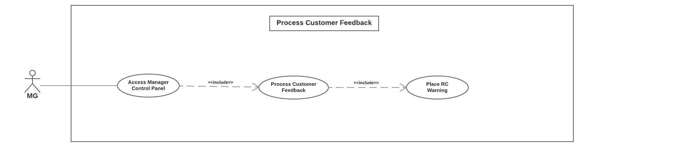

Collaboration diagram:

Confidential ©Senior Design with Prof:Izidor Gertner., 2017 Page 13
LiveTranslation

Software Requirements Specification

<document identifier>

Version: 1.0

Date: 25/10/2017
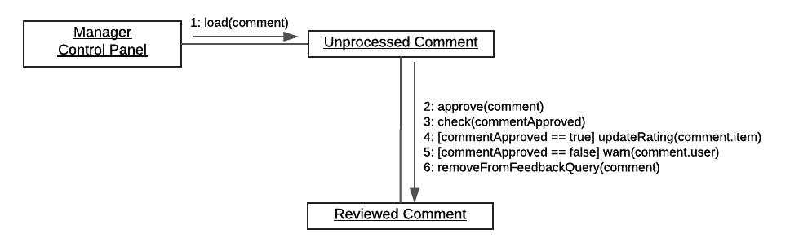

Petri-net: (See 2.2.3)

Description: MG is granted special access through the MG-CP (manager control panel). This control panel
allows MG to process feedback given by RC.
Details:

Accepting a comment
- User logs in as MG
- MG accesses MG-CP
- MG views unprocessed feedback provided by RC
- MG confirms and accepts feedback
- SY updates the average rating of the restaurant or menu item Placing a warning

- User logs in as MG
- MG accesses MG-CP
- MG views unprocessed feedback provided by RC
- MG flags RC for inappropriate feedback

2.2.7 Managing employees

Use case diagram:
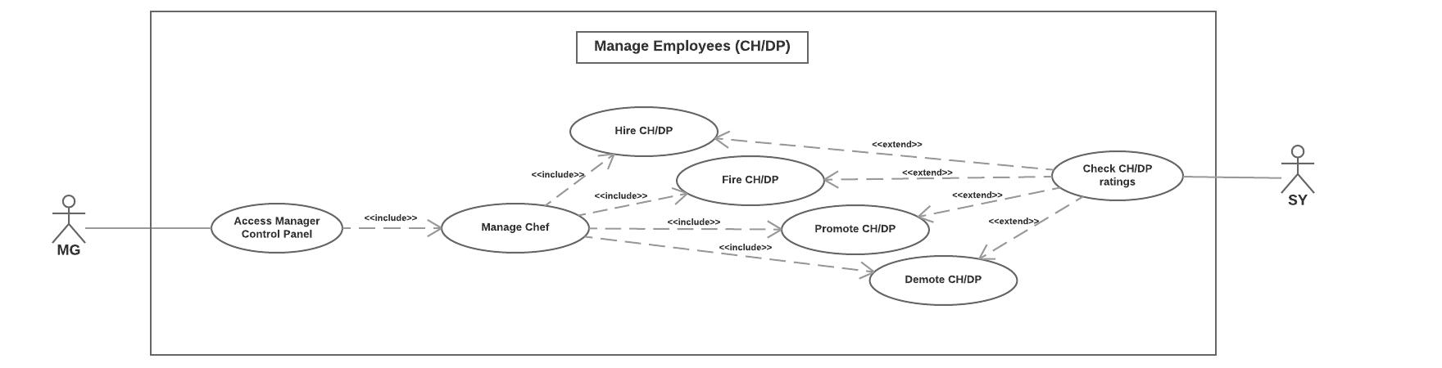

Collaboration diagram:
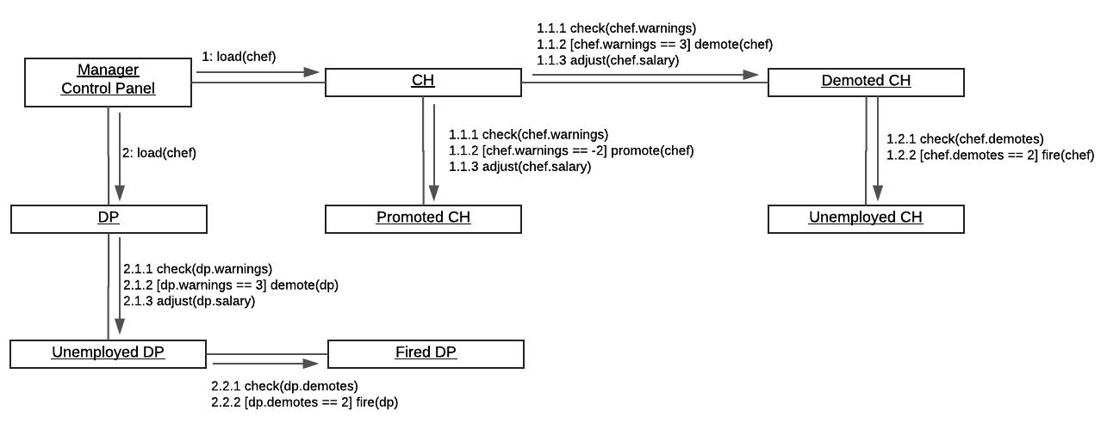

Petri-net:

Confidential ©Senior Design with Prof:Izidor Gertner., 2017 Page 14
LiveTranslation

Software Requirements Specification

<document identifier>

Version: 1.0

Date: 25/10/2017
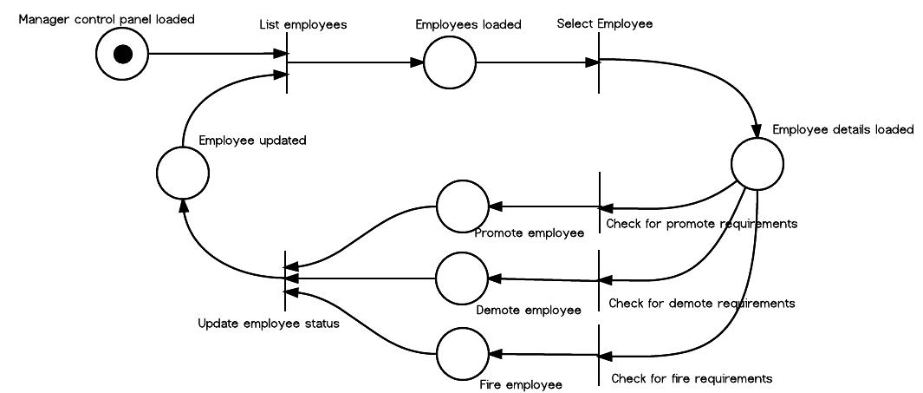

Description: MG is granted special access through the MG-CP (manager control panel). This control panel allows MG to manage the employees of the restaurant (CH and DP). Details:

Hiring
- User logs in as MG
- MG accesses MG-CP
- MG views CH or DP operating at current restaurant
- MG hires CH or DP
Firing
- Users logs in as MG
- MG accesses MG-CP
- MG views a CH or a DP
- MG prepares to fire CH or DP
- SY checks for ratings of CH or DP and approves of fire
- CH or DP is de-registered from current restaurant Promoting

- User logs in as MG
- MG accesses MG-CP
- MG views a CH or a DP
- MG prepares to promote CH or DP
- SY checks for ratings of CH or DP and approves the promotion
- CH or DP is promoted
- SY adjusts salary of selected CH or DP
Promoting
- User logs in as MG
- MG accesses MG-CP
- MG views a CH or a DP
- MG prepares to promote CH or DP
- SY checks for ratings of CH or DP and approves the demotion
- CH or DP is demoted
- SY adjusts salary of selected CH or DP

2.2.8 Delivering orders

Use case diagram:
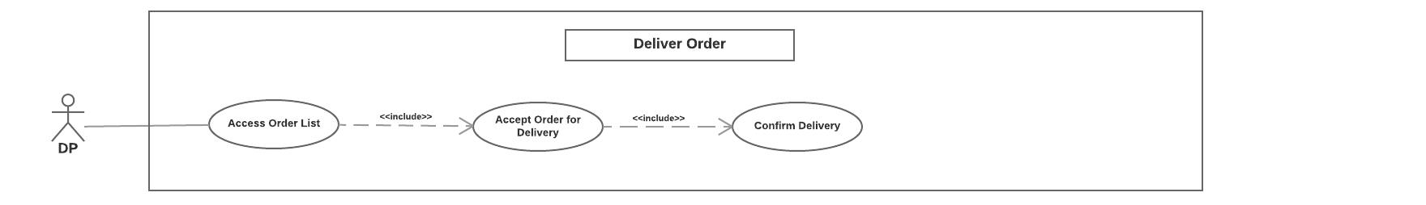

Confidential ©Senior Design with Prof:Izidor Gertner., 2017 Page 15
LiveTranslation

Software Requirements Specification

<document identifier>

Version: 1.0

Date: 25/10/2017

Collaboration diagram:
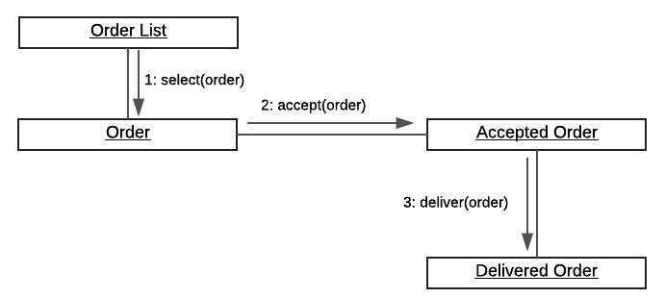

Petri-net: (See 2.2.3)

Description: Delivery personnel (DP) has access to a list of orders placed by RC and proceeds to delivery to
the RC location.
Details:
- User logs in as DP
- DP views list of orders for current restaurant
- DP accepts an order to deliver
- DP delivers and confirms that the order has been delivered

2.2.9 Preparing the menu

Use case diagram:
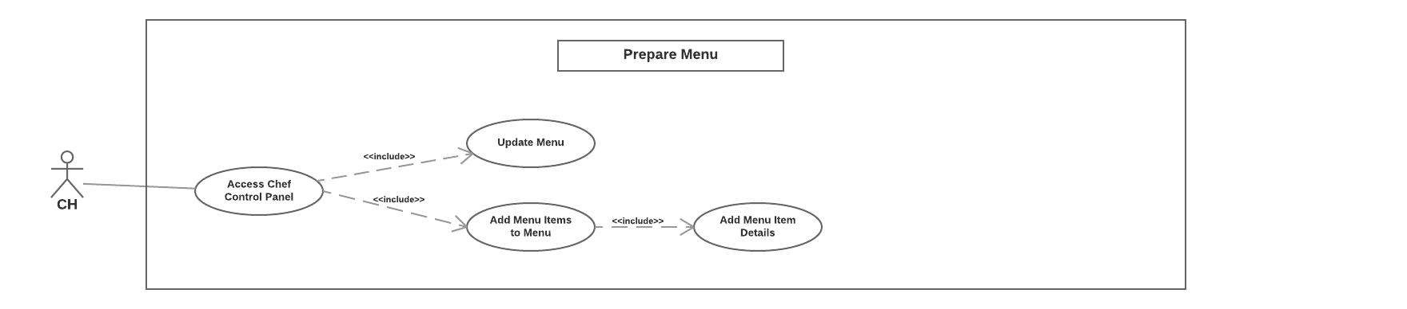

Collaboration diagram:
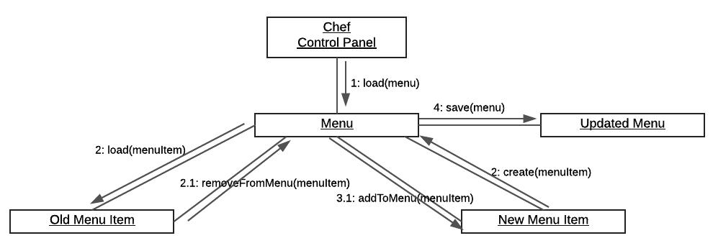

Petri-net:

Confidential ©Senior Design with Prof:Izidor Gertner., 2017 Page 16
LiveTranslation

Software Requirements Specification

<document identifier>
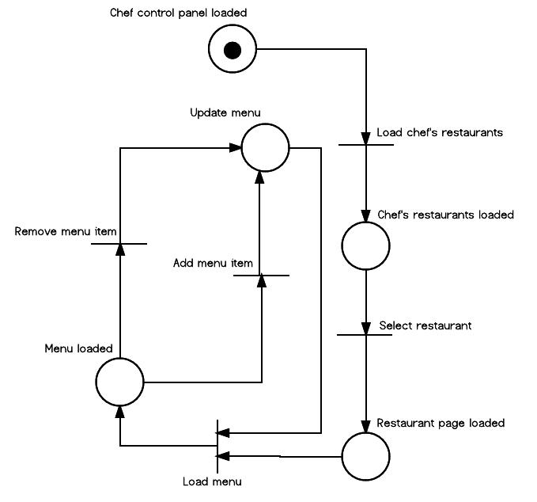

Version: 1.0

Date: 25/10/2017

Description: Chefs (CH) have access to a special chef control panel (CH-CP), which allows the CH to alter the menu.

Details:
  - User logs in as CH
  - CH accesses CH-CP
  - CH views menu of current restaurant
  - CH adds or removes menu items
  - CH updates or saves the new menu

- Entity Relationships

3.1 E-R Diagram

Confidential ©Senior Design with Prof:Izidor Gertner., 2017 Page 17
LiveTranslation

Software Requirements Specification

<document identifier>
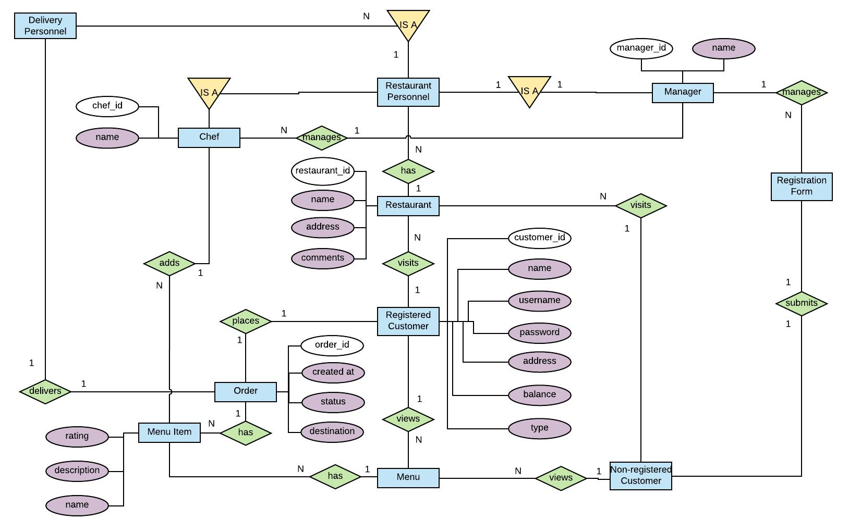

Version: 1.0

Date: 25/10/2017

- Detailed Design

4.1 Pseudo-code

This section provides pseudo-code for major components of the LiveTranslation system. These modules are categorized by general processes such as registrations (and de-registrations), ordering, and basic UI sequences done by the system. The functions are represented by underscore-separated phrases followed by parameters within parenthesis (inputs) followed by a set of procedures within brackets {outputs}.

4.1.1 Registration Processing

submit_register_form {

Initialize user_info hash (name_field:, password_field:)
Initialize name, password

Input valid name

Input valid password

Add user_info to RC-waitlist database

}

register_customer(user_info) {

If user_info is denied by MG

Return ERROR_INVALID_USER
Initialize empty RC

RC.name = user_info.name

RC.password = user_info.password

Add RC to RC-entity database
}

deregister_customer(user) - Remove user from RC database

4.1.2 Order processing

place_order(cart_items[], user, restaurant {

Initialize order_sum to zero
Initialize empty order

For each item in cart_items

Add item.price to order_sum

If user is a VIP

Confidential ©Senior Design with Prof:Izidor Gertner., 2017 Page 18
LiveTranslation

Software Requirements Specification

<document identifier>

Version: 1.0

Date: 25/10/2017

Reduce order_sum to 90%

Update UI

Add cart_items and user_id to order

If user balance <= order_sum

Add order to restaurant.orders

Go to confirm order page

}

confirm_order(order, restaurant) - Add order to restaurant.orders

receive_order(order, restaurant) - Remove order from restaurant.orders

update_ratings(order, restaurant) {

For each item in order.items

Initialize chef to item.chef

Update item rating
update_employee_rating(chef, item.rating)

}

4.1.3 Account management

deposit(user) {

Initialize balance to user.balance

Initialize credit card information
Input credit card information

Input deposit amount

If valid credit card

Transfer deposit amount

}

update_address(user) - Update user address

4.1.4 Restaurant management

place_rc_warninig(feedback) {

Feedback.user.warnings++
If warnings > 3

deregister_user(feedback.user)

}

update_menu(restaurant, menu_items) {

restaurant.menu_items is menu_items
Update restaurant menu_items database

update_employee_rating(employee, rating) {

Let employee be CH or DP
If rating is < 3

employee.flags--

If rating is > 3
employees.flags++

If employees.flags < 3

employees.rating--

If employees.flags > 3
employees.rating++

If employees.rating = 5

employees.salary++

If employees.rating = 0
employees.salary--

employees.demotes++

If employees.demotes = 2

Remove employees from restaurant.employees

}

4.1.5 GUI Sequences

load_restaurant_page(restaurant) {

Load html w

Confidential ©Senior Design with Prof:Izidor Gertner., 2017 Page 19
LiveTranslation

Software Requirements Specification

<document identifier>

Version: 1.0

Date: 25/10/2017

Get restaurant from database

load_menu()
load_details()

}

load_menu(restaurant) - Load menu items of restaurant

load_details(restaurant) - Load location, reviews, description of restaurant

load_menu(user) {

If user is NC

Show top_dishes[5]

Else if user is RC

Show user.top_dishes[5]

Show rest of menu

}

- System Screens

5.1 Homepage screens

5.2.1 Homepage (NC)
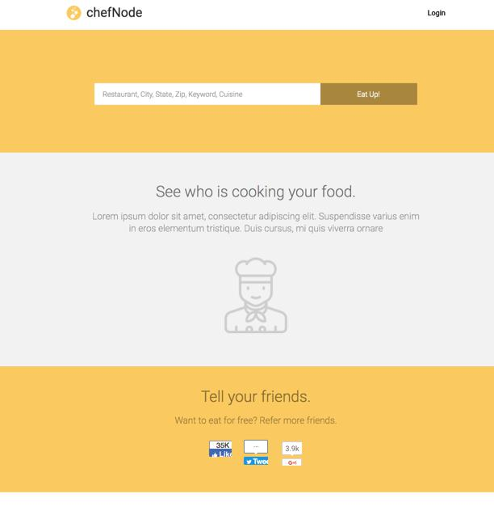

5.2.1 Homepage (RC)

Confidential ©Senior Design with Prof:Izidor Gertner., 2017 Page 20
LiveTranslation

Software Requirements Specification

<document identifier>

Version: 1.0

Date: 25/10/2017

5.2 Registered users

5.2.1 Account settings
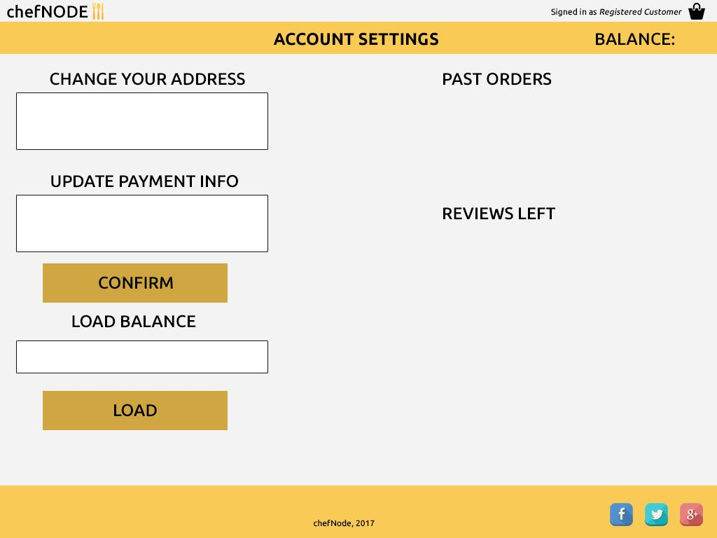

5.2.2 Checkout

Confidential ©Senior Design with Prof:Izidor Gertner., 2017 Page 21
LiveTranslation

Software Requirements Specification

<document identifier>
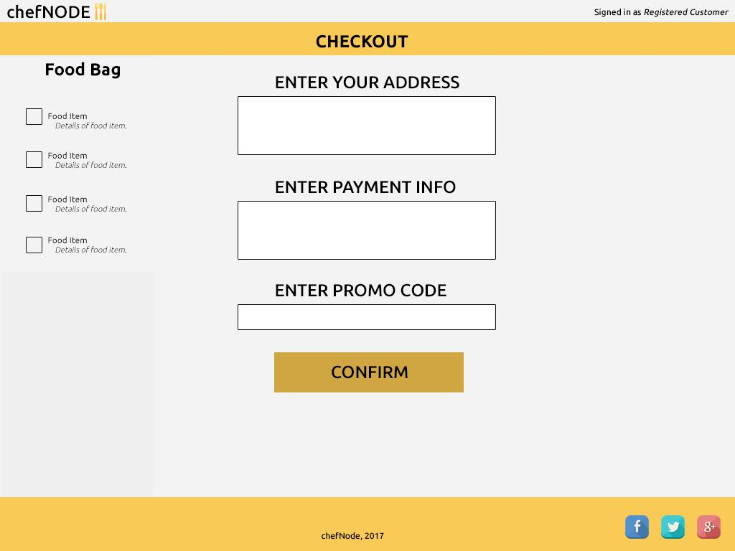

Version: 1.0

Date: 25/10/2017

5.3 Restaurant

5.3.1 Restaurant page
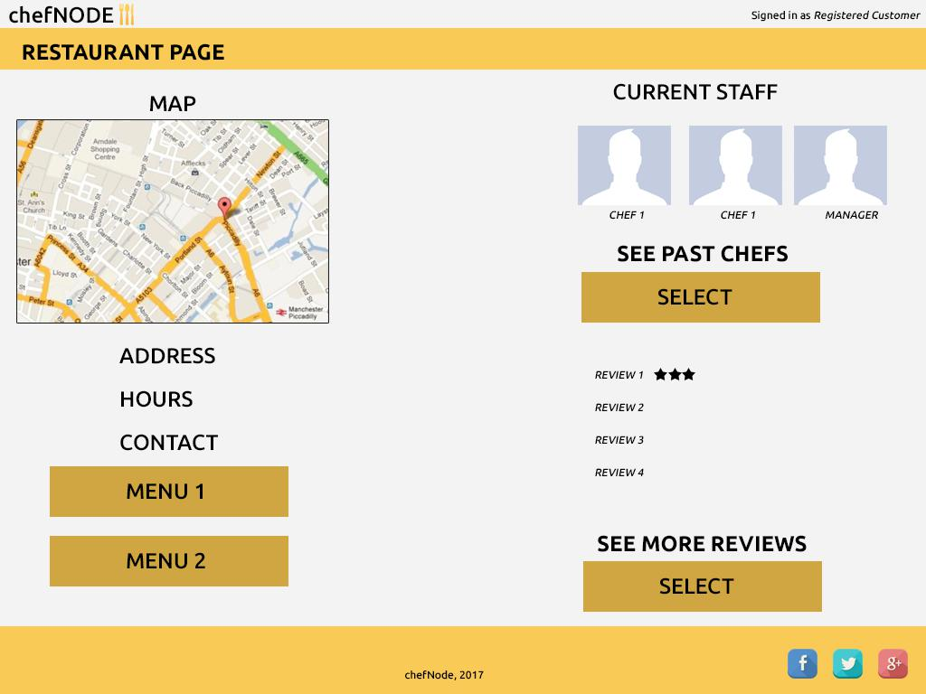

Confidential ©Senior Design with Prof:Izidor Gertner., 2017 Page 22
LiveTranslation

Software Requirements Specification

<document identifier>

Version: 1.0

Date: 25/10/2017

5.3.2 Restaurant menu page (NC)
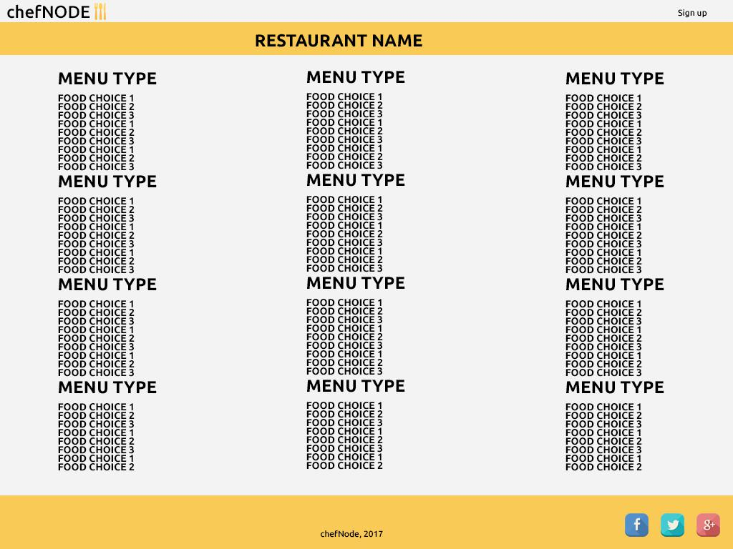

5.3.2 Restaurant menu page (RC)
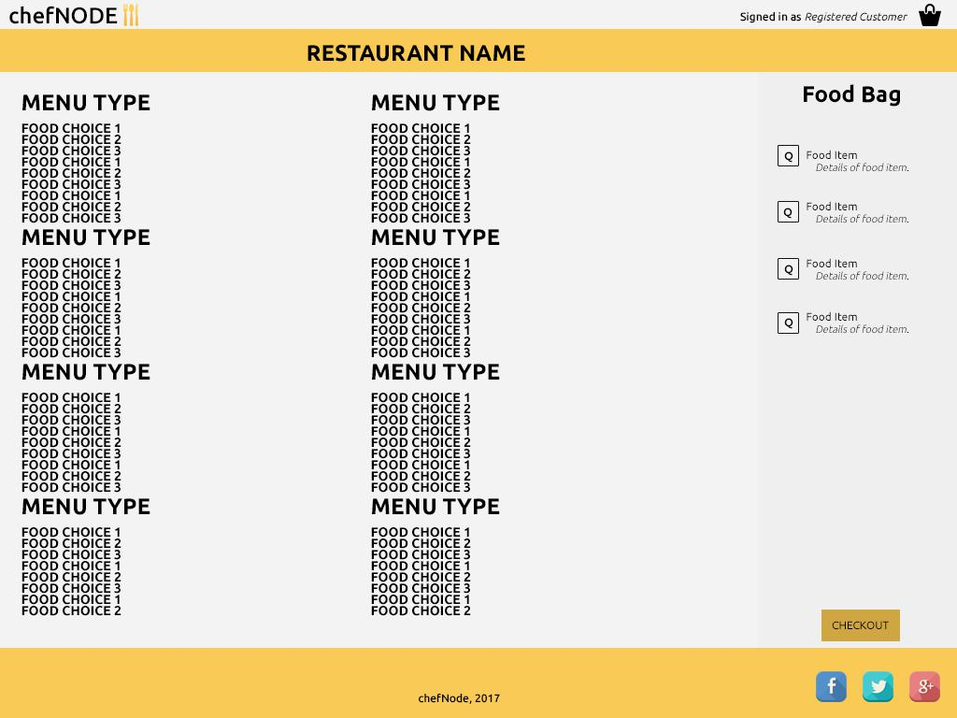

5.4 Restaurant personnel

Confidential ©Senior Design with Prof:Izidor Gertner., 2017 Page 23
LiveTranslation

Software Requirements Specification

<document identifier>

Version: 1.0

Date: 25/10/2017

5.4.1 Chef control panel
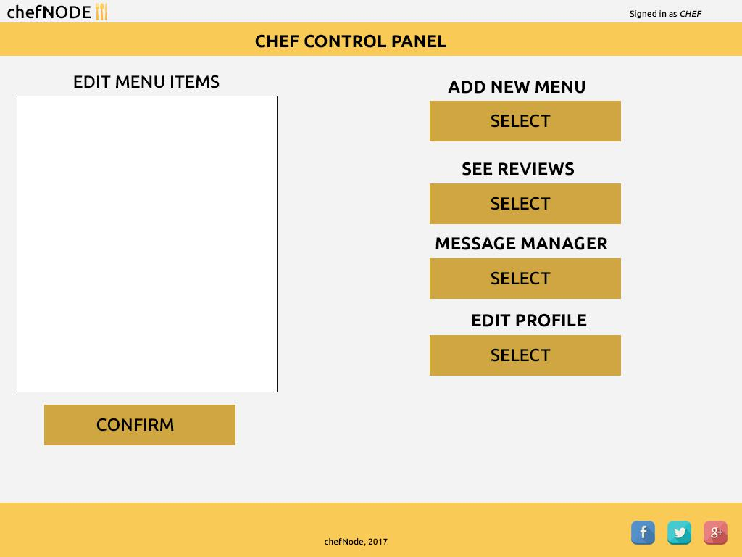

5.4.2 Delivery personnel control panel
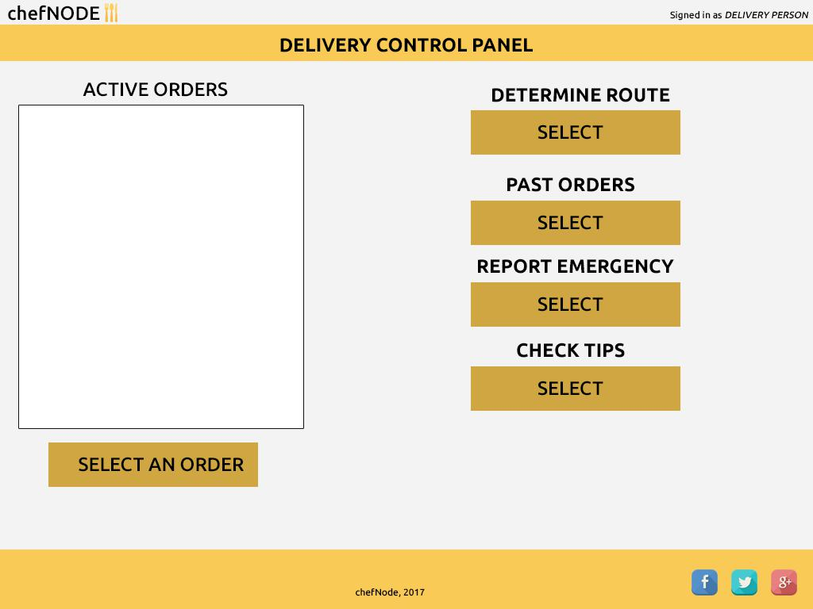

Confidential ©Senior Design with Prof:Izidor Gertner., 2017 Page 24
LiveTranslation

Software Requirements Specification

<document identifier>

Version: 1.0

Date: 25/10/2017

5.4.3 Manager control panel
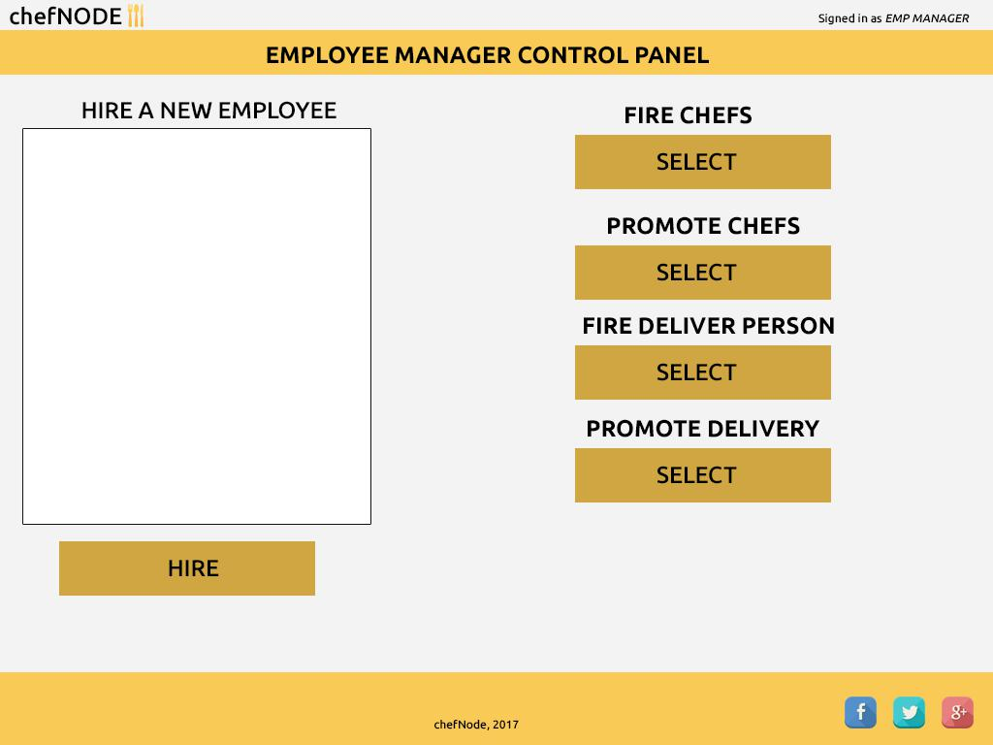

5.5 Searching and browsing

5.5.1 Searching as a non-registered user
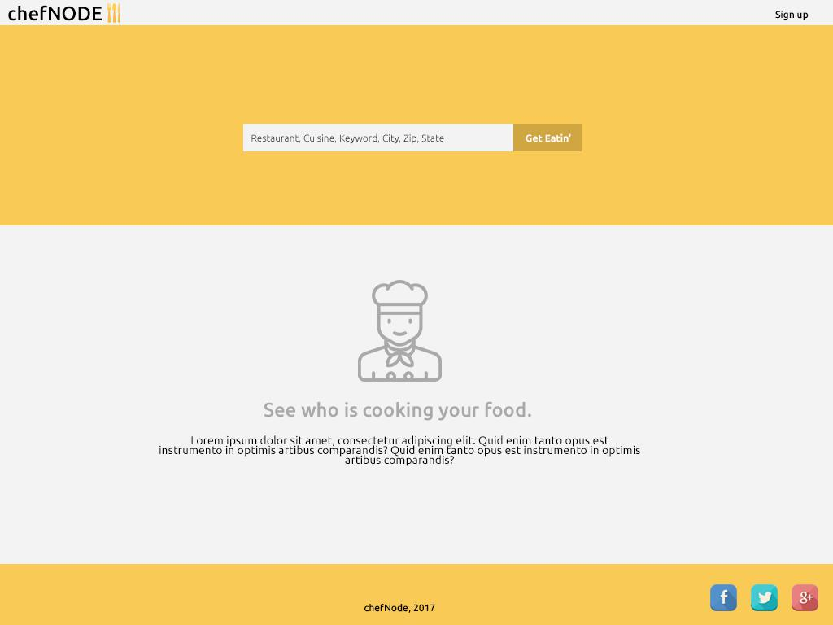

Confidential ©Senior Design with Prof:Izidor Gertner., 2017 Page 25
LiveTranslation

Software Requirements Specification

<document identifier>

Version: 1.0

Date: 25/10/2017

5.5.2 Searching as a registered user
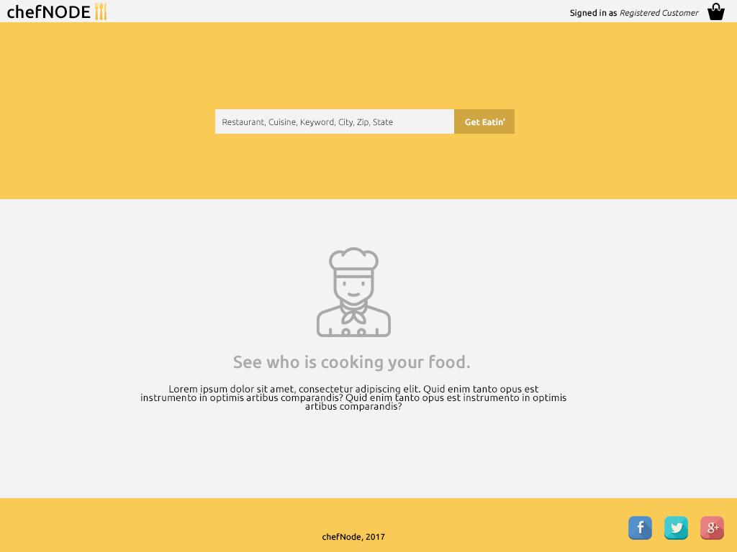

e

5.5.3 Search results
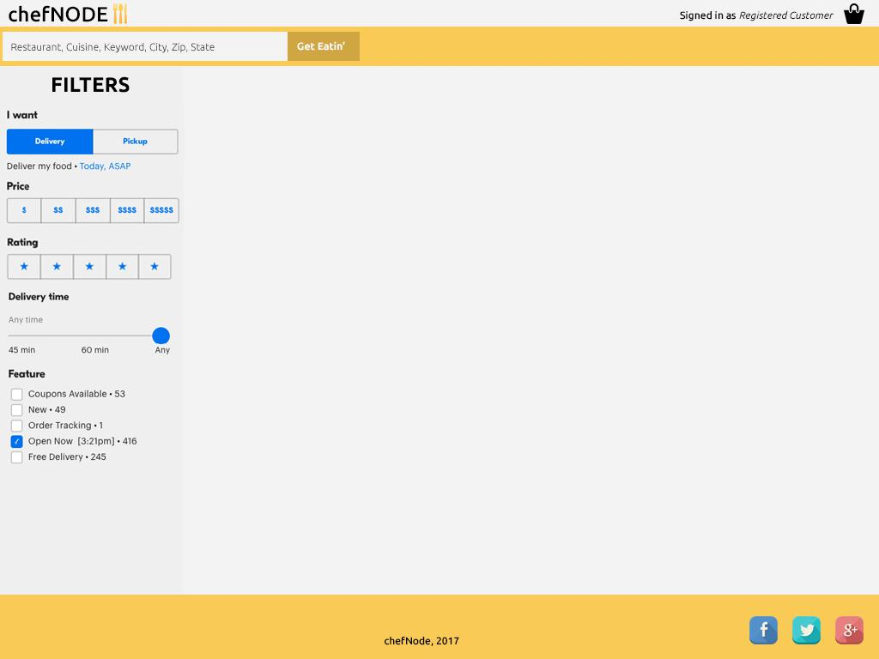

Confidential ©Senior Design with Prof:Izidor Gertner., 2017 Page 26
LiveTranslation

Software Requirements Specification

<document identifier>

Version: 1.0

Date: 25/10/2017

5.6 System

5.6.1 Administrator control panel
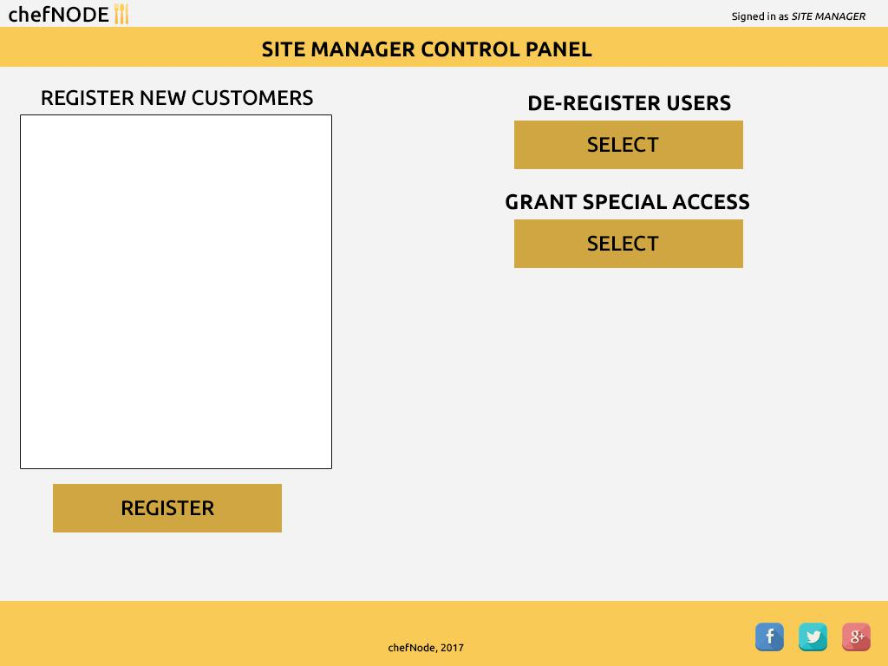

Confidential ©Senior Design with Prof:Izidor Gertner., 2017 Page 27

